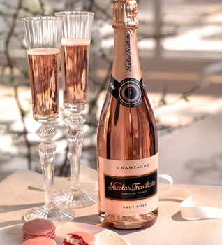

Blend:
A deliciously fruity blend. A selection of several cru wines creating Champagne of great freshness and elegance.
“A HARMONIOUS, FRUITY CHAMPAGNE REVEALING A SALMON-PINK HUE.”

Appearance:
Silver-tinged salmon-pink, with a steady ribbon of fine bubbles.

Nose:
Red fruit aromas. Intense, developing notes of blueberry, blackcurrant and raspberry.

Palate:
Delicate on the palate, fluid, underpinned by an extremely fine bead. Fruity finish.
For an aperitif, best served at 7 - 8°C.
With food, best served at 10 - 12°C.

Food and wine pairings:
Aperitif: Salmon and avocado blinis
Starter: Chicken and vegetable samosas
Main: Pork Nuoc-Mam with soy beans
Dessert: Gariguette strawberry souffle tart

